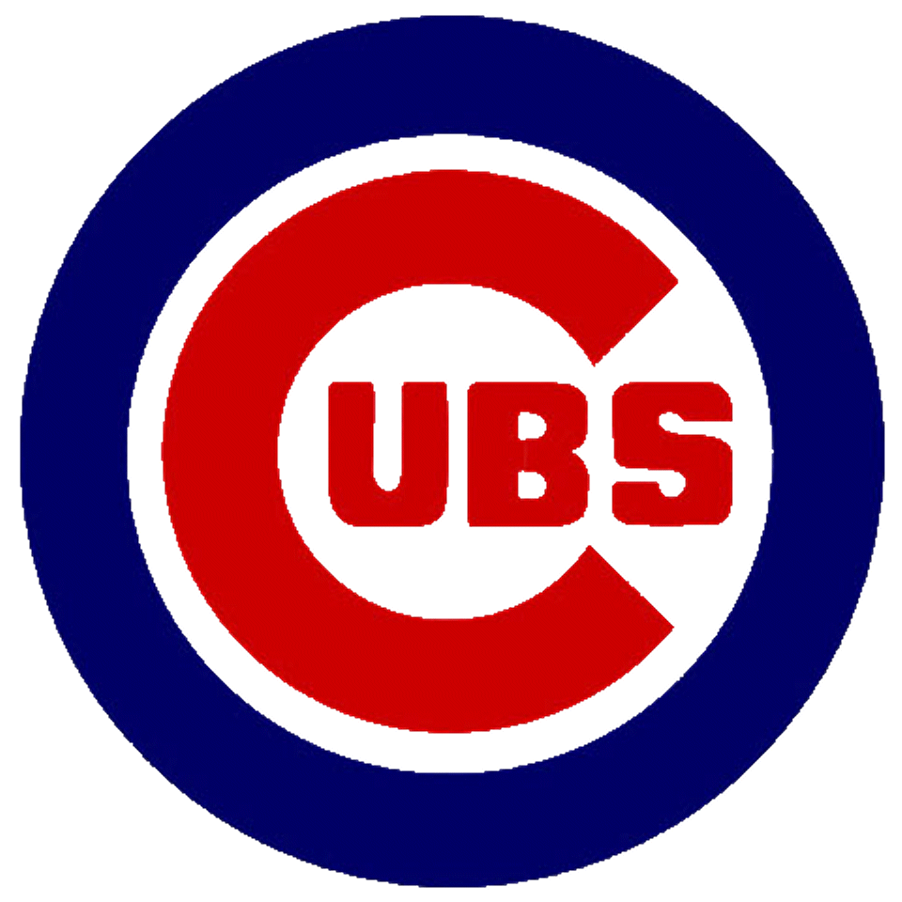 Rotary Family Day at the Ball Park 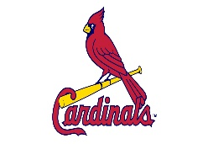
Cubs vs. Cardinals
Saturday, July 13 at 1:15 P.M. – Busch Stadium

Please use this form to order tickets.

Name__________________________________ Phone ____________________

Address__________________________________________________________
Street City Zip code

Email Address_____________________________________________________

Rotary Club________________________________________________________

# of Tickets: _______ ordered at $60.00 = _________

Make checks payable to Rotary District 6460, and mail ticket order form and check to: Janet Ellis-Nelson, 1905 Moraine Drive, Champaign, IL 61822. Tickets will be mailed to you.

RULES:
- First come. First served.
- No tickets can be returned. Tickets cannot be sold on any site.
- No refunds.

